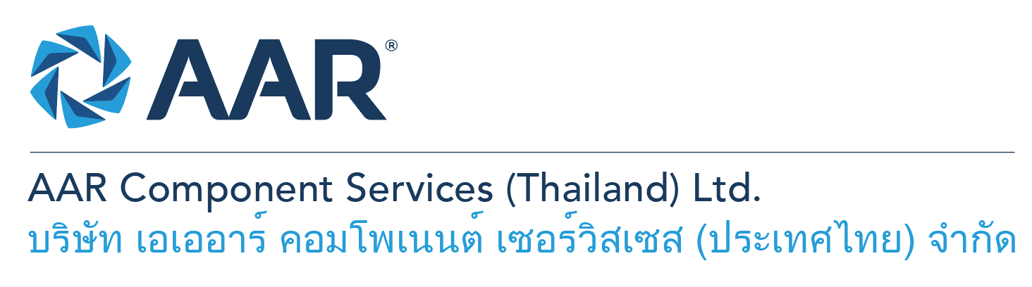

**Aircraft Materials Purchasing (Components)**

**Quick AAR information / resources**

**Website:** [aarcorp.com](https://www.aarcorp.com/)

**Careers:** [aarcorp.com/careers](https://www.aarcorp.com/careers/)

**Email:** ACSTH-Recruitment@aarcorp.com

**The position**

We are looking for Aircraft Materials Purchasing (Components). The Materials Purchasing is responsible for the material planning and purchasing to support repair orders, part provisioning (Safety stock) and input forecast from competitive, high quality and reliable suppliers/vendors and also managing optimum inventory level by products.

**Key Roles & Responsibilities:**

* Source material both domestic and oversea and negotiate to get the best sources with competitive price, high-quality and short lead time.
* Source qualified vendors who have repair/fabrication capabilities and special processes (plating, anodizing, heat treatment, machining, welding, etc.)
* Co-ordinate with Quality department for vendor/supplier account setup and approval of supplier Class 1-4.
* Follow up suppliers/vendors for shipping details and work with Logistic and warehouse to ensure that all deliveries are satisfied and filled the assigned purchase orders and report any back-ordered or missing products.
* Ensuring the products are delivered on time by supplier management which include payment terms, cost savings, materials quality.
* Work with planners and operations internally to achieve defined planned material clear date and operation target date to meet company goal and customer TAT.
* Input accurate data in Syteline MRP and monitor all open purchase orders.
* Issue purchase orders and repair orders per SRO Transactions to supplier/vendors.
* Place orders on web portal
* Work with suppliers/manufactures and engineering team for extending shelf-life materials.
* Launch annual RFQ for safety stock items and negotiate with suppliers for the best prices and short lead times.
* Initiate and execute project improvements for process efficiency and cost reduction.
* Create item master in Syteline MRP.
* Attend engineering workscope of each SRO for the customer requirements and part provisioning and required materials.
* Provide a list of scrapped parts of each SRO to Engineering to review for repair development or alternative material (Shortage or long lead times)
* Work with Operations and Engineering to ensure SRO transactions (Planned material and labor hours) are complete.
* Generate the plan cost of each SRO and update planned material and plan cost , and close gate in Syteline MRP.
* Determine the required materials in SRO transactions and generate purchase order requisition and purchase order.
* Ensure materials meet specifications, quality standards, and are cost-efficient.
* Review and monitor material arrival dates and provide SRO material clear dates to Operations.
* Work with Store to pick materials per SRO Transactions.
* Monitor complete SROs for cost completion and close gate in Syteline MRP.
* Monthly accrue cost for incomplete cost posting of each order and update to Finance department.

**Qualifications:**

* Bachelor’s degree in Business or related field
* Ability to read, write and understand English and computer literacy is required
* Good verbal and written English communication skills.
* Excellent verbal and written English communication skills.
* Minimum 2 years in associate buyer/planner or 5 years of related aviation supply chain role
* Proficiency in computer skills (MS Word, Office, Excel, ERP systems)

**Total rewards**

As an AAR team member your rewards include:

* Annual uniform
* PPE safety equipment
* Transportation
* Vacation benefits, including Thai Public Holidays
* Provident Fund
* Group Insurance
* Training and development opportunities
* Staff engagement and recognition events

**Performance objectives**

* **Teamwork** – collaborates with colleagues to achieve results and is also comfortable working independently
* **Building trust** – operates with integrity, discloses own positions, remains open to ideas, and supports others through dignity, respect, and fairness
* **Building relationships and partnerships** – develops and leverages relationships within and across teams to achieve results
* **Communication** – conveys information and ideas clearly and concisely to individuals or group in an engaging manner, helping them understand and retain the message
* **Analytical skills** – must be able to use data to determine cause and effect for complex problem solving
* **Quality orientation** – accomplishes tasks by considering all areas involved, no matter how detailed

**Why should you apply?**

* AAR is the only aerospace / defense company on Forbes’ America’s Best Mid-Size Employers list.
* Our innovative and entrepreneurial culture encourages employee input in every aspect, from day-to-day activities to the company’s future growth.
* Our learning and career development program affords employees a learning path with the necessary tools and resources needed to help build their career at AAR.
* We support non-profits and organizations that work to improve society in four primary areas: veterans and active military; education with an emphasis on STEM; health and wellness; and diversity / inclusion.

**About AAR**

AAR is an awarded global aerospace and defense company that offers employees a long-term career pathway and the opportunity to work with a great team! At AAR, our people remain our priority! We create the #BestTeamInAviation by focusing on recruitment, training, growth, engagement, and retention. AAR employees are empowered to meet their individual professional development goals through our global learning and development program, mentorship program, leadership training, continued education, networking, and much more!

AAR is committed to building a diverse and inclusive workforce. We encourage applications from people of all races, ethnic origins, religions, abilities, sexual orientations, gender identities, or expressions. We are dedicated to the health and safety of our people, our customers, and the communities where we live and work.

**Primary Location**: 700/160 Amata City Chonburi Industrial Estate Moo1, T. Bankao, A. Pantong, Chonburi, 20160 Thailand.

Qualified applicants may email their resume to [ACSTH-Recruitment@aarcorp.com](mailto:ACSTH-Recruitment@aarcorp.com)

Please submit your resume in PDF format.

Although all applications are appreciated, only those candidates selected for an interview will be contacted.